From <http://arstechnica.com/gadgets/2016/02/pentium-core-i5-core-i7-making-sense-of-intels-convoluted-cpu-lineup/>

# Pentium? Core i5? Core i7? Making sense of Intel’s convoluted CPU lineup

## It defies simple explanation, but here's how to know what you're getting.

by [**Andrew Cunningham**](http://arstechnica.com/author/andrew_cunningham/) - Feb 27, 2016

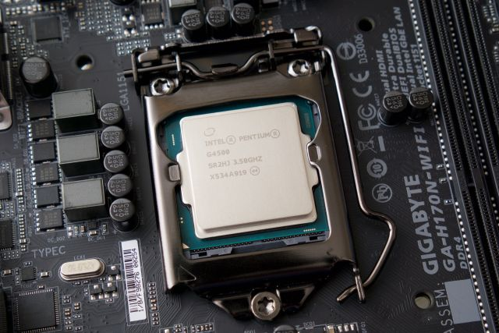

Intel's Skylake-based Pentium G4500.

Andrew Cunningham

Our creative director Aurich Lawson is building a PC to power a custom arcade cabinet, and he was having trouble picking a processor. Not because he didn’t know what he needed, but because he was having trouble matching what he needed (the cheapest quad-core CPU that meets the recommended requirements for Street Fighter V) with what Intel was offering (five different obfuscated brands spread out over multiple sockets and architectures).

And if you’re building a PC now after having been out of the game for a few years, it can be exceptionally confusing. Around the turn of the millennium you just had Celeron and Pentium. One name meant “cut-down low-end” and one meant “high-end, more features,” and you just bought the fastest one you could reasonably afford. Things got a little more confusing in the Core and Core 2 days (the Core branding continues to survive alongside the Celeron and Pentium brands), but you could at least use names like “Core Solo” and “Core 2 Quad” to guess which architecture and how many cores you were getting. Now there are

1. three separate Core brands,
2. Pentium and Celeron brands, and
3. a long series of letters that you need to know to figure out what CPU you’re getting.

It's been a few years since the last time we demystified Intel’s CPU lineup, and in truth things haven’t changed too much. In broad strokes, the rules are the same. But Intel has introduced and retired a few CPU architectures and brands since then. We’ll run down the basics for both desktops and laptops to help you make some sense of things whether you’re building a computer or buying one from someone else.

## First: Know your architectures

Right this second we’re in a sort of transitional phase where some old CPUs are still filtering out as new ones filter in. In brief:

The **old** chips, codenamed Haswell, are generally identifiable by their 4000-series model numbers or the “4th generation Core” label. The desktop chips use **socket 1150** motherboards. In general, we would recommend against considering these for new builds or purchases unless you can get a really good deal—Haswell is at the end of its life and Intel won’t be making new chips for its socket in the future. There are also a handful of 5000-series, 5th-generation **Broadwell** desktop chips that use the same socket—Intel didn't do a full release of these CPUs because of manufacturing delays, so you'll find the majority of them in laptops instead.

The **new** chips, codenamed Skylake, have 6000-series model numbers and a “6th generation Core” label. The desktop chips use **socket 1151** motherboards, which is likely (not guaranteed, but likely) to see additional use in the upcoming **Kaby Lake** and **Cannonlake** architectures later this year and into next year. If you care at all about future-proofing, the small price premium is worth paying if you're building a desktop.

## Desktops: Celeron, Pentium, Core****i3 and Corei5****

These  **five separate processor brands** all share the Skylake architecture and the 1151 socket. I’ll list the high-level differences of each along with exceptions, and then we’ll get into model number suffixes.

### Celerons and Pentiums

Both of these are budget brand names, and processors in both lines tend to be differentiated by clock speed and not much else.

Skylake Pentiums are G4000-series chips, while Celerons are G3000-series. They’re all dual-core CPUs with no Turbo Boost, no Hyperthreading, and 3MB of cache, and they’re typically paired with the basic Intel HD 510 integrated GPU.

Core i3 CPUs are a little faster, but **Pentiums will give most price-conscious people the best bang for their buck**.

**Exceptions**: The [Pentium G4500-series](http://ark.intel.com/products/series/90990/Intel-Pentium-Processor-G4500-Series-For-Desktop#@Desktop) chips get an Intel HD 530 GPU that’s quite a bit faster than the 510 (within the realm of integrated graphics, anyway).

### Core i3

These CPUs are still dual-core but add **Hyperthreading**, which presents two logical processor cores to the operating system for every physical core. This can definitely help performance in multithreaded workloads, though it’s nowhere near the boost you’d get from moving to a quad-core CPU. Core i3-6100 CPUs include 3MB of cache while 6300-series chips include 4MB of cache; nearly all of them use the Intel HD 530 GPU.

**Exceptions**: The [Core i3-6098P](http://ark.intel.com/products/93366/Intel-Core-i3-6098P-Processor-3M-Cache-3_60-GHz) uses an Intel HD 510 GPU.

### Core i5

These are all quad-core CPUs without Hyperthreading, and they **probably represent the best balance of price and performance for high-end users**. They also use Intel’s Turbo Boost feature, which let the CPU run at higher clock speeds when there’s enough thermal headroom or when fewer cores are being actively used.

Not all workloads will benefit from two extra processor cores, but video editing, Photoshop work, and an increasingly large number of games are all happier with four cores. All of these CPUs include 6MB of cache and most of them have Intel HD 530 GPUs.

**Exceptions**: The Core i5-6402P includes an Intel HD 510 GPU.

### Core i7

These are best described as Core i5 chips but with Hyperthreading, higher clock speeds, and and 8MB of cache. Otherwise they’re the same. As with Core i3 CPUs, Hyperthreading definitely does help performance in heavily threaded programs, but jumping from a Pentium or Core i3 to a Core i5 will get you a much larger performance bump than jumping from an i5 to an i7.

**Exceptions**: None. There aren’t many of these processors yet.

### Desktop Processor suffixes

The Celeron, Pentium, and various Core labels tell you *most* of what you need to know about a given CPU, but the model number suffix is important too. Here’s what these suffixes mean (and note that some CPUs have more than one letter attached).

**No suffix**: These are “mainstream” CPUs with no particularly special properties.

**T-series**: These are low-power desktop chips with lower TDP values, which generally (but not always) translates into lower power consumption. These power savings are usually realized by reducing the CPUs’ maximum clock speed. For example, a [Core i7-6700](http://ark.intel.com/products/88196/Intel-Core-i7-6700-Processor-8M-Cache-up-to-4_00-GHz) has a TDP of 65W, a base frequency of 3.4GHz, and a Turbo frequency of 4.0GHz. A [Core i7-6700T](http://ark.intel.com/products/88200/Intel-Core-i7-6700T-Processor-8M-Cache-up-to-3_60-GHz) has a TDP of 35W, a base frequency of 2.8GHz, and a max clock speed of 3.6GHz.

**K-series**: This relatively rare suffix denotes a multiplier-unlocked CPU that can be overclocked when paired with a [high-end Intel Z170 chipset](http://ark.intel.com/products/90591/Intel-GL82Z170-PCH). The chips also have a higher 91W TDP, relative to the standard 65W for a quad-core CPU.

**E-series**: E is for “embedded,” which implies that these are mostly going to come with pre-built systems or soldered to motherboards. System builders can mostly ignore this one.

**P-series**: Back in the Core 2 days, a P-series chipset didn’t include an integrated GPU. Now, P-series chips just include *slower* integrated GPUs. Go figure.

## Laptops: A big ol’ mess

If you thought the desktop lineup was complicated, wait until you see how messy the laptop lineup is! In this case, the processor suffixes are a better way to keep track of the different processors. The different processor brandings mean different things based on the amount of power the CPU is designed to use and the kind of system it was designed to fit in.

As with the desktop Core i3, i5, and i7 chips, 4000-series means Haswell, 5000-series means Broadwell, and 6000-series means Skylake. Each successive CPU generation includes minor-to-negligible improvements in CPU performance alongside more tangible improvements to GPU performance, something to keep in mind as you decide whether to buy something cutting-edge or save money on an older or refurbished model. Since upgrading the processor isn't even possible most of the time, you can worry less about having a future-proofed motherboard. That said, we'll focus primarily on Skylake here.

### Laptop processor suffixes

[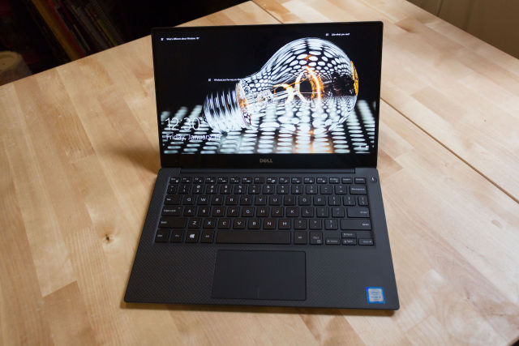](http://cdn.arstechnica.net/wp-content/uploads/2016/02/IMG_2743.jpg)

Thin-and-light Ultrabooks like Dell's XPS 13 use dual-core U-series processors, which are the most common laptop chips Intel sells.

Peter Bright

**U-series**

These are all dual-core processors that have become Intel’s bread-and-butter laptop chips, in everything from high-end Ultrabooks to mainstream laptops to low-end models (though the low-end Celeron and Pentium U models appear less often in budget laptops than Atom-derived versions we’ll talk about shortly).

There are three different types of U-series Core i3, i5, and i7 Skylake processors, differentiated by their TDPs and integrated graphics processors. One way to tell is by the four-digit model number: if it ends in two zeroes, it’s a 15W processor with an Intel HD 520 GPU. If it ends in the number 50 or 60, it’s a 15W processor with an Intel Iris 540 GPU, which adds 64MB of eDRAM to alleviate memory bottlenecks. If it ends in a 7, it’s got an Intel Iris 550 GPU and a higher 28W TDP which means that both CPU and GPU can run at higher speeds for longer amounts of time.

U-series Celerons are dual-core chips with 2MB of cache and an Intel HD 510 GPU. Pentiums and better include Hyperthreading. Core i3s include 3MB of cache, Core i5s and better add Turbo Boost, and Core i7s include 4MB of cache. Core i3s, i5s, and i7s all include either an Intel HD 520 GPU or an Iris 540/550 GPU as outlined above. Whew.

**HQ-series**

This one applies only to Core i5 and i7 chips, so at least there are only a few of them to keep track of. Again, you’ll need to know a combination of the suffix and the model number to get the full picture.

These are all quad-core processors; Core i5s have 6MB of cache and Core i7s include 8MB of cache and Hyperthreading. Some members of the family come with beefier integrated GPUs than others, though, and that’s where model numbers come in.

If the model number ends with the numbers 50 or 70 (for Core i5s and i7s, respectively), you’ve got a chip with Intel’s Iris Pro Graphics 580 GPU, the most powerful integrated GPU Intel has ever shipped. Thanks to an increased number of execution units (EUs) and 128MB of eDRAM cache, Iris Pro performance approaches that of a midrange dedicated GPU. That eDRAM can also serve as a fast memory cache for the CPU, which will provide a speed boost to certain workloads that have nothing to do with graphics.

If the processor model number ends with anything else—00, 20, or 40—you’ve got an Intel HD 530 GPU with no eDRAM. These processors are significantly cheaper than the Iris Pro versions and their processor cores may be able to run faster for longer since they’re not sharing a CPU package with a big GPU and a bunch of eDRAM. You just have to live with the lower graphics performance (and lack of extra cache memory) that comes with it.

**HK-series**

Only one CPU belongs to this family: The [Core i7-6820HK](http://ark.intel.com/products/88969/Intel-Core-i7-6820HK-Processor-8M-Cache-up-to-3_60-GHz). It’s an unclocked, overclockable quad-core laptop processor. If you’re the kind of person who thinks that sounds like a good idea, go to town.

**H-series**

Another rare suffix which as of this writing applies only to the [Core i3-6100H](http://ark.intel.com/products/89063/Intel-Core-i3-6100H-Processor-3M-Cache-2_70-GHz). This denotes a dual-core CPU with Hyperthreading and a 35W TDP, considerably higher than the more common U-series. The extra TDP headroom will let it run at its max speed of 2.7GHz for longer periods of time, and it makes room for an HD 530 GPU, slightly better than the HD 520 GPU more common in the U-series. The H series seems to be a replacement for the bygone M-series, which used to be Intel’s mainstream dual-core laptop chips until the U-series improved enough to totally replace them.

### Low-power and low-end: Core M and Braswell (respectively)

[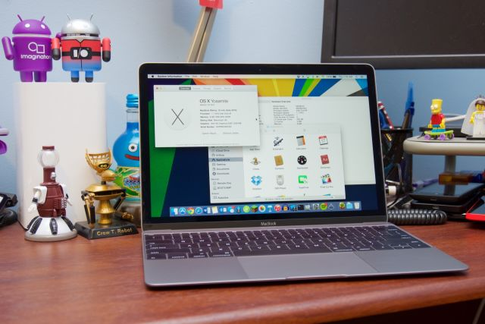](http://cdn.arstechnica.net/wp-content/uploads/2016/02/DSC00385.jpg)

Skinny, fanless laptops like Apple's MacBook use Core M CPUs instead.

Andrew Cunningham

**Core M**

These get their own category because they're a special case. As of Skylake, Intel has three Core M brands: Core m3, m5, and m7. All of them are dual-core CPUs with Hyperthreading, Turbo Boost, 4MB of cache, and an Intel HD 515 GPU. From a user’s perspective, the only real difference is peak clock speed, which ranges from 2.2GHz for the Core m3 up to 3.1GHz for the Core m7.

These processors have rather low base frequencies and rely on Turbo Boost to keep systems feeling responsive, so they’ll be more prone to throttling than U-series chips or others with higher TDPs (Core M is designed to fit into a 4.5W TDP, less than a third of a U-series chip). In exchange, systems that use Core M are often totally fanless, which is easy to get used to if you’re coming from a standard Windows laptop with an overactive fan.

The Skylake version of Core M isn’t bad, but at this point we’d recommend against buying the older Broadwell version of Core M (which is *just* sold as Core M, not Core m3/m5/m7). Its performance was less consistent and more compromised, and [in our testing](http://arstechnica.com/gadgets/2015/11/review-asus-excellent-midrange-laptop-gets-much-better-with-skylake/) the Skylake version has been a significant step up in every way.

**N3000-series Celerons and Pentiums**

These chips are sold under the Celeron and Pentium branding but they use a different CPU architecture called “Airmont.” These chips (also referred to as “Braswell” when you’re talking about the entire chip instead of just the CPU) have lower CPU and GPU performance, and are generally found only in entry-level PCs and Chromebooks.

These Celerons and Pentiums aren’t all that bad in and of themselves, but the unfortunate fact is that they’re usually paired with slower storage and paltry amounts of RAM.

## It’s not my fault this is so confusing

The days when Intel processors were differentiated mostly by clock speed are long past, and as Intel has gotten more serious about GPUs the integrated graphics chip the processors come with has just become another piece of the puzzle. And we didn’t even touch the Xeon chips that you can consider if you’re really looking at a high-end workstation.

If you’re building a desktop, at least, things are pretty clean. If you want a quad-core, get the best Core i5 you can afford; if you’re on a budget, the dual-core Pentium chips give you solid value for the money. Laptops are harder to figure out, but as long as you keep your eyes open and figure out the model number you ought to be able to avoid unpleasant surprises.

[READER COMMENTS 211](http://arstechnica.com/gadgets/2016/02/pentium-core-i5-core-i7-making-sense-of-intels-convoluted-cpu-lineup/?comments=1)